Themeauswahl
Die Auswahl an Wordpress Themes ist riesig. Die vorinstallierten Themes sind unten gelistet. Auf Anfrage können wir gerne weitere Themes installieren. Bitte nehme hierzu Kontakt mit uns auf. Weitere Themes findest du unter folgendem Link:
http://wordpress.org/extend/themes/

Standardtheme
Das Standardtheme basiert auf dem Theme „blass“. Dieses ist unter anderem um das Feature "Dynamic Headers" erweitert. Damit ist es möglich ein eigenes Profilbild hochzuladen.

Demo: http://blog.stud.uni-goettingen.de/studit/

angel
Angel is a light colored theme with widget ready sidebars.
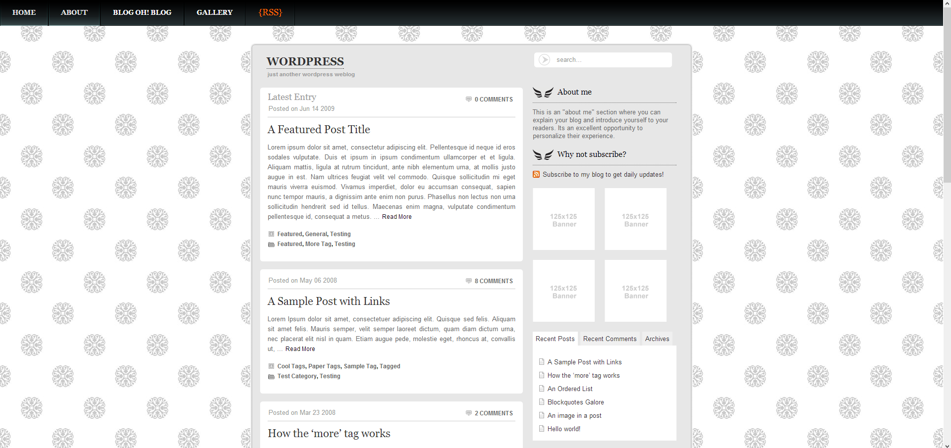
Demo: http://wpthemes.blogohblog.net/
Demo: http://wpthemes.blogohblog.net/

blacksapphire
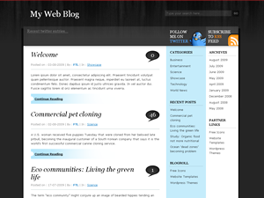
Demo: http://www.freethemelayouts.com/blog/

Blass
Elegantes, widgetfähiges Theme, das komplett ohne Bilddateien auskommt.
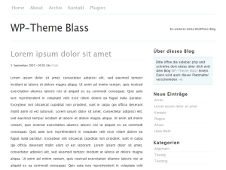
Demo:

Capricorn
Capricorn is a light simple one cloumn theme, designed for people with simple taste.
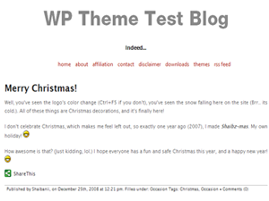
Demo:

ChocoTheme
Stylish WordPress theme with two columns, right-sidebar. 3 color schemes availible. Theme options panel for background and navigation configuration.
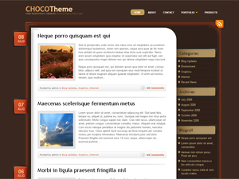
Demo:

Clear
Clear is the perfect theme for great authors. It is clean, clear and beautiful. It is minimalistic one-cloumn theme with the widgets all arranged at the bottom. Clear was designed to make your content stand out and make everything else get out of the way.
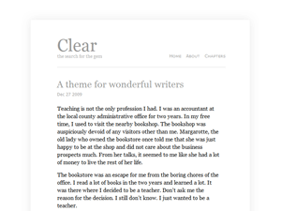
Demo:

Contempt v2
Contempt based on Kubrick.
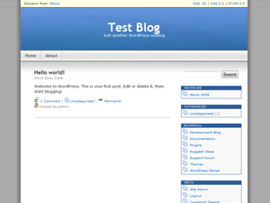
Demo:

Frisco for BuddyPress
Derived almost entirely from the BuddyPress Default theme, Frisco for BuddyPress adds some minor HTML changes and a fresh coat of CSS.
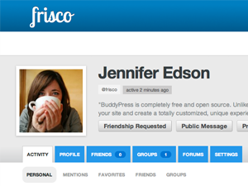
Demo:

Greyzed
Greyzed Wordpress Theme by The Forge Web Creations
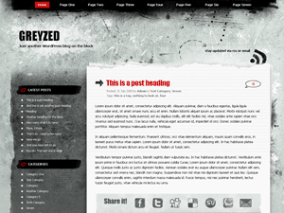
Demo:

iDream
WordPress theme with two columns, four widget areas. The theme options include a removable bottom sidebar, category or page navigation, custom copyright notice. It comes with optional graphic logo.
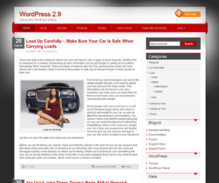
Demo:

Journalist
Journalist is a smart, minimal theme designed for professional journalists.
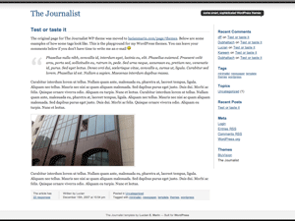
Demo:

jQ
m34 of jQuery functions as well as a practical theme options page. The design is clean and solid, valid CSS and XHTML. Features: threaded comments, drop-down navigation, different styles and more.
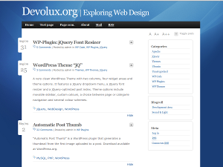
Demo:

Manifest
A clean and streamlined theme that focuses on the content and not the distractions.
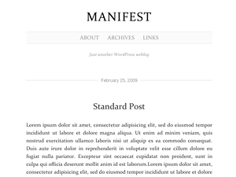
Demo:

nightgate
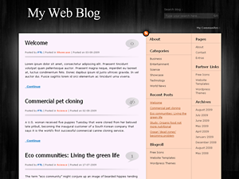
Demo:

Shuttershot
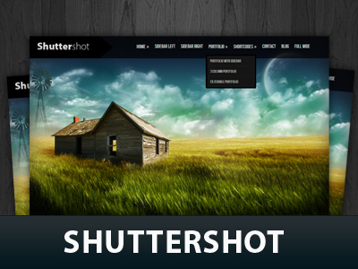
Demo:

Simple WP Community Theme
Simple WP Community Theme is a three-columns, widget-ready Buddypress theme. It comes in a dark dressy design with a community-navigation widget. It is 100% WP 3.0 compatible, e.g. custom menus. Also it has a custom header to change text color or add a logo or background-image.
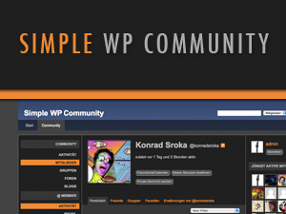
Demo:

Wallbase
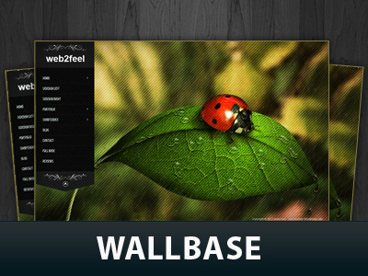
Demo:

zBench
It is a simple WordPress theme without any plugin needed (support plugin WP-PageNavi, WP Page Numbers, WP-PostViews, wp-utf8-excerpt, Related Posts of Simple Tags, WP-RecentComments), little images, custom-menu, widgets, threaded-comments.
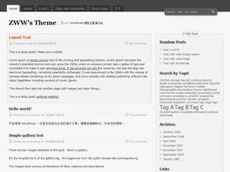
Demo:

