LRC KWZ
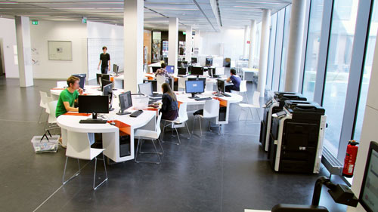
The LRC KWZ is a co-operative effort of Göttingen State and University Library, the cultural studies divisional library, GWDG and studIT. You can find further information concerning the LRC KWZ on our support homepage or on the pages of the Göttingen State and University Library.

The consulting hours are:
- Monday, Wednesday, Friday 10 am to 2 pm
- Tuesday and Thursday 1 pm to 5 pm

The opening hours are:
You can use all services of the LRC KWZ during the opening hours of the cultural studies divisional library:
- Monday to Friday 7 am to 10 pm
- Saturday 10 am to 6 pm
There you can use the following services:
- issuing of guest accounts
- resetting and regeneration of passwords for the student account (and also for the self-service functions)
- regular advice and assistance concerning the student account (including support concerning the Wi-Fi networks
- advice concerning printer queues and printers
- expert consulting regarding the use of programs for academic purposes
You can find us on the ground floor at the consulting counter.
tag> studIT support LRC KWZ cultural studies divisional library

