studIT Facebook Page
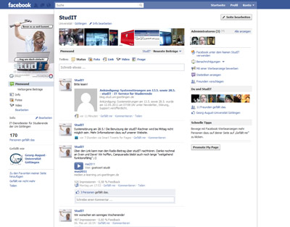
studIT has an own Facebook page where you can find the latest news and links concerning student IT at Göttingen University. Our Twitter stream provides you with current failure reports and information about our systems. You can find photos, videos and much more there, too. Just have a look and do not miss any important information about studIT. We look forward to you liking our page!
studIT Facebook page
studIT Twitter account
tag>facebook facebook.com facebook page twitter tweet like fan social network socialnetwork

